SCIENCE OF CHANGE COMPANION TOOL
The Wheel of Feelings
Get precise about what you feel so you know how to manage it.
One of MOVE's three lenses — Science of Change — asks what's happening in the brain and body of the people carrying a change. Ever replay a situation, wishing you'd shown up differently? Maybe you’re working with a stakeholder group who is openly resistant to a change and can’t name why. Being precise about feelings can help us skillfully find and apply strategies to address those feelings. In this worksheet, work through a moment that's bugging you or a ask stakeholders to get specific about what they’re resisting.

Bonus Activity: Use the Wheel as a stand-alone tool during celebrations. Also use in meetings where people are getting stuck during decision making due to unclear feelings.
1. What happened? Give me the short version of the situation.
Click or tap here to enter text.
2. Start at the center of the wheel. What's the general feeling this situation brought up?
Click or tap here to enter text.
3. Now trace it out one ring. Which word nails it? If that’s not exactly it, go to question 4.
Click or tap here to enter text.
4. Go one more ring if you need to. What's the most precise word for what you felt?
Click or tap here to enter text.
Example: “Bad” → “Stressed” → “Overwhelmed.” That's the level of specific you're after.
5. What about the situation caused that feeling? Be specific — what happened right before you felt it?
Click or tap here to enter text.
6. How did you react based on that feeling? What did you say, do, or think — about the other person, about yourself?
Click or tap here to enter text.
7. Did you respond the way you wanted to? If so, what worked? What did you do right?
Click or tap here to enter text.
8. If not, what got in the way? What would you do, say, or think differently next time?
Click or tap here to enter text.
9. How do you set yourself up to show up in the way you’d like to if a future situation like this one? Click or tap here to enter text.
THE WHEEL OF FEELINGS
Center to edge. General to specific.
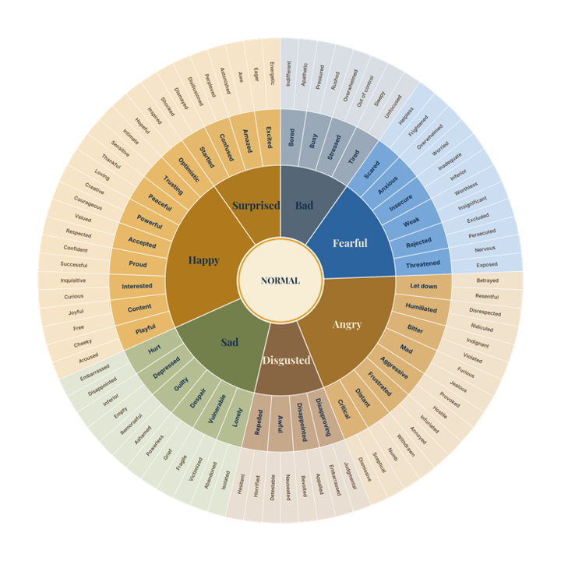

To see the full framework → The MOVE Framework
Discover something you want to talk through? Send your questions or schedule a chat.
Did someone send you this? Check out my other resources at www.updikecoaching.com

