COACHING COMPANION TOOL
The Wheel of Values
Not what you value — how engaged you are with your values.
This one's less about naming your values — most people can do that in five minutes — and more about seeing where the gap is between what you say matters and how it actually shows up in your week. Eight sections, eight values, one honest wheel.
Bonus Activity: Use when planning a change to determine if a change and its outcomes align with the organization’s values. Write the organization’s values in the outside rings and map level that outcome will support the organization’s values. Also works with teams.
This wheel is centered on: ☐ Work ☐ Personal ☐ Both
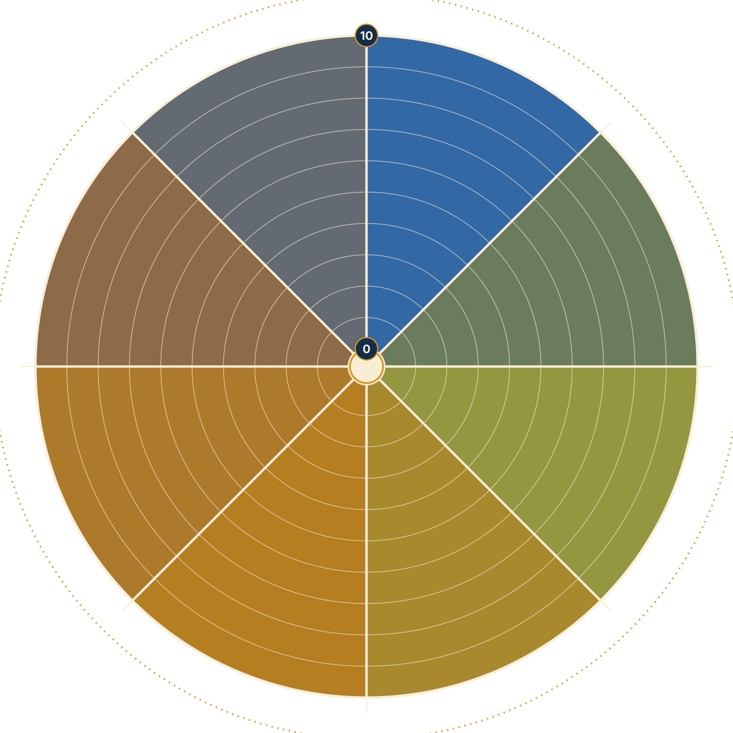
HOW TO FILL IT OUT
- Label each of the 8 sections with a value — write it just outside the wheel, in the dotted ring. (Word list on the next page if you want a starting point.)
- The center of the wheel is 0. The outer edge is 10.
- For each value, draw a line across the section at the point that matches how satisfied you are with how engaged you are with it — not how important it is, how present it is.
- Write the number next to your line.
- Look at the new shape those lines make. That's your Wheel of Values. Is it a bumpy ride?
- What is one action you could take to find more alignment with your values?

Values, for a starting point
1. Empathy
2. Compassion
3. Integrity
4. Respect
5. Kindness
6. Honesty
7. Generosity
8. Gratitude
9. Forgiveness
10. Tolerance
11. Humility
12. Patience
13. Responsibility
14. Fairness
15. Courage
16. Wisdom
17. Love
18. Trust
19. Understanding
20. Open-mindedness
21. Acceptance
22. Cooperation
23. Harmony
24. Loyalty
25. Self-discipline
26. Resilience
27. Authenticity
28. Accountability
29. Justice
30. Equality
31. Unity
32. Altruism
33. Optimism
34. Serenity
35. Appreciation
36. Dignity
37. Courtesy
38. Modesty
39. Balance
40. Flexibility
41. Persistence
42. Creativity
43. Resourcefulness
44. Adaptability
45. Independence
46. Sincerity
47. Self-awareness
48. Growth
49. Communication
50. Harmony
51. Security
52. Stability
53. Hope
54. Peace
55. Self-care
56. Innovation
57. Curiosity
58. Exploration
59. Freedom
60. Community
61. Sustainability
62. Environmental stewardship
63. Mindfulness
64. Inclusivity
65. Collaboration
66. Authentic connection
67. Joy
68. Vitality
69. Purpose
70. Fulfillment
71. Integrity
72. Adventure
73. Wonder
74. Respect for diversity
75. Honoring tradition
76. Compassionate listening
77. Adaptation
78. Prudence
79. Sensitivity
80. Graciousness
81. Self-reflection
82. Empowerment
83. Rationality
84. Curiosity
85. Equanimity
86. Honoring commitments
87. Interdependence
88. Spiritual growth
89. Holistic health
90. Self-expression
91. Reverence for life
92. Global citizenship
93. Mind-body connection
94. Frugality
95. Ethical conduct
96. Inner peace
97. Environmental consciousness
98. Philanthropy
99. Selflessness
This list is here to get you started. If you hold a value that isn't on it, use it.

Discover something you want to talk through? Send your questions or schedule a chat.
Did someone send you this? Check out my other resources at www.updikecoaching.com

